**Name:** Phan Tran Thanh Huy

**ID:** ITCSIU22056

Lab 6

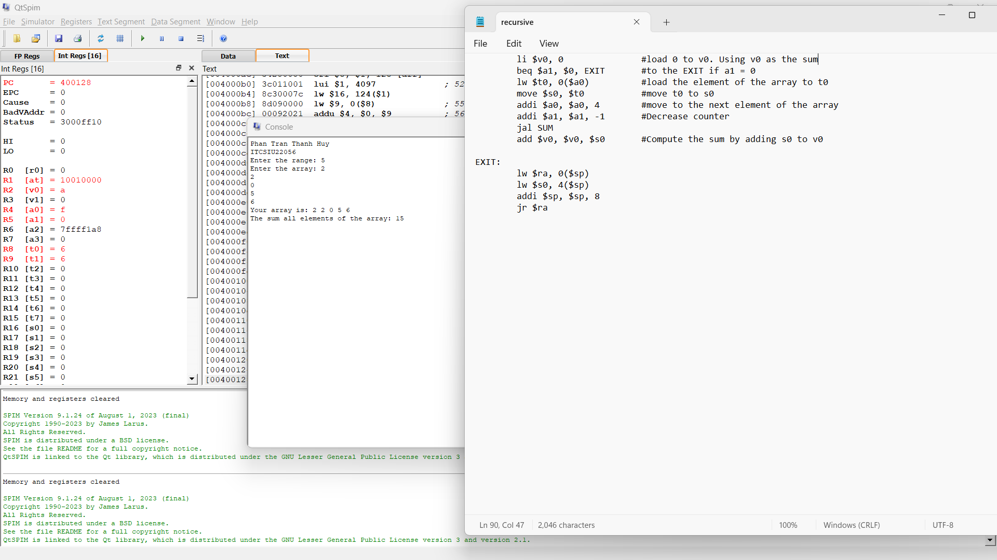

**Code:**

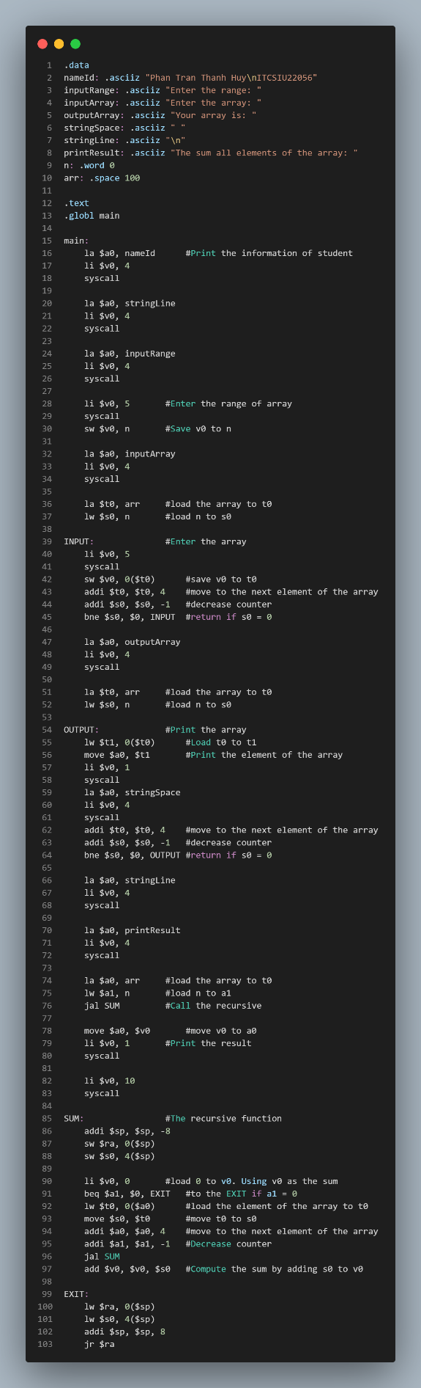

**Result:**

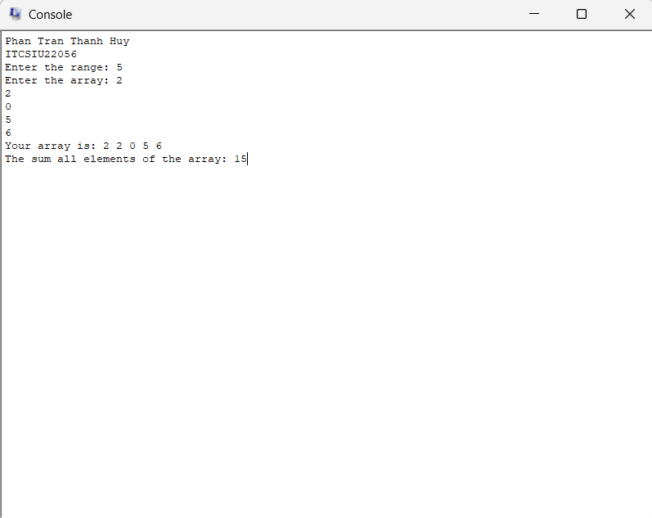

**Explaination of the address:**

Before calling the procedure SUM, the initial return address is stored in memory address [00400018] and the initial stack pointer address is stored in memory address [7ffff19c].

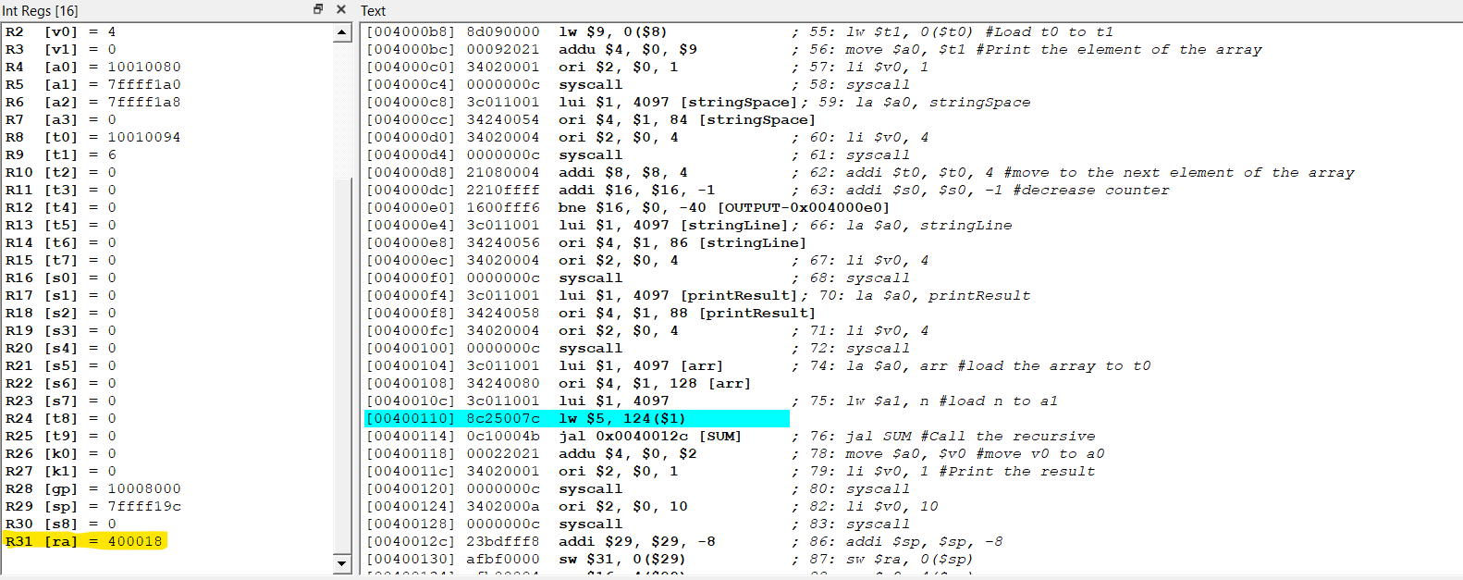

After calling the procedure SUM, the return address is stored in memory address [00400118], which is the return address of the callee to the main function.

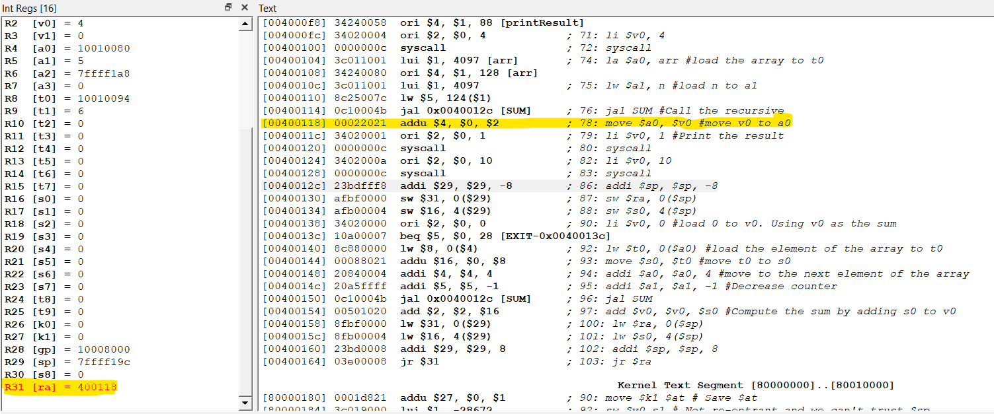

And the stack pointer is stored in memory address [7ffff194]

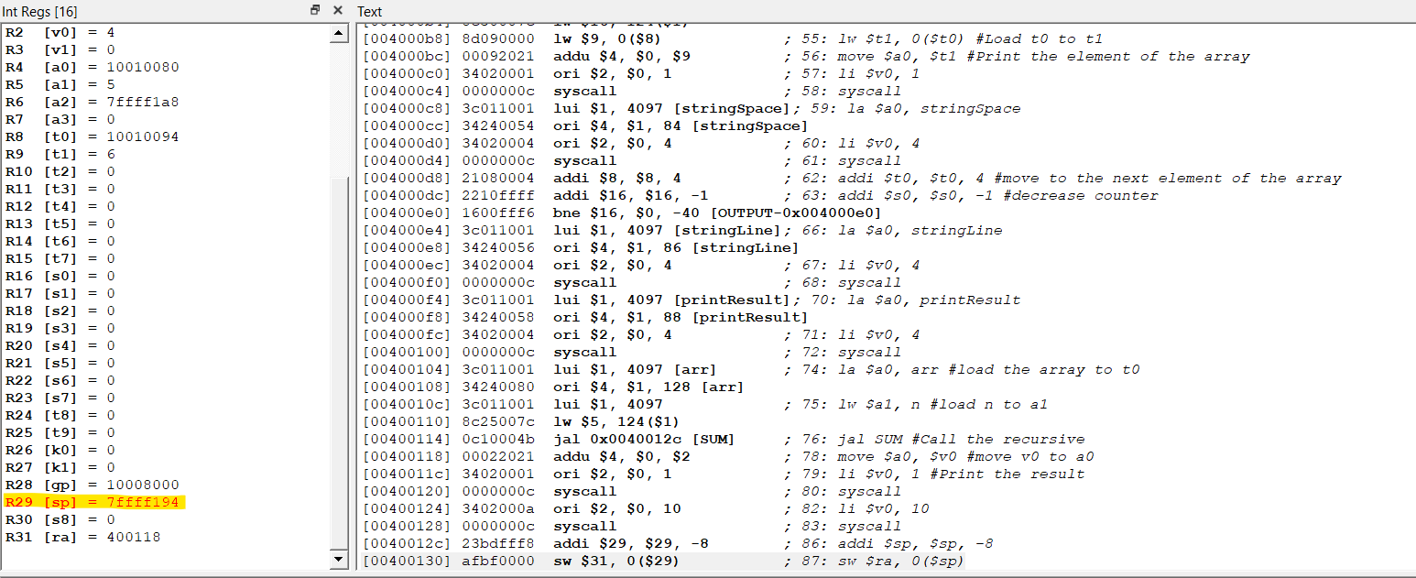

In the first save, the stack pointer is stored in memory address [7ffff18c] and the return address is stored in memory address [00400154], which is the return address of the add operation.

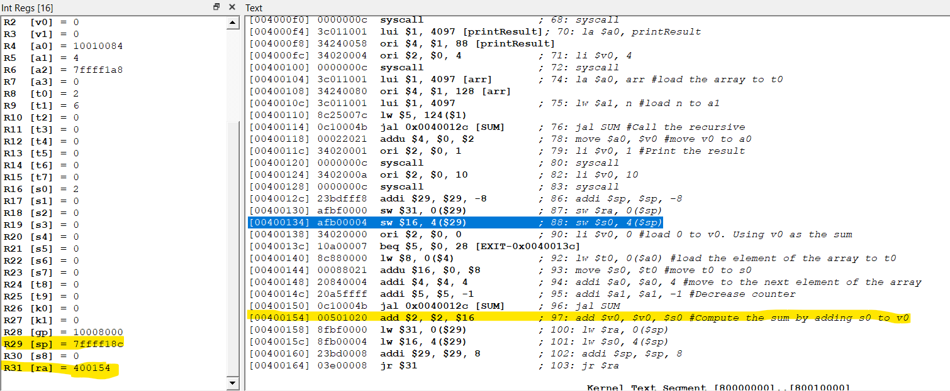

In the second save, the stack pointer is stored in memory address [7ffff184]

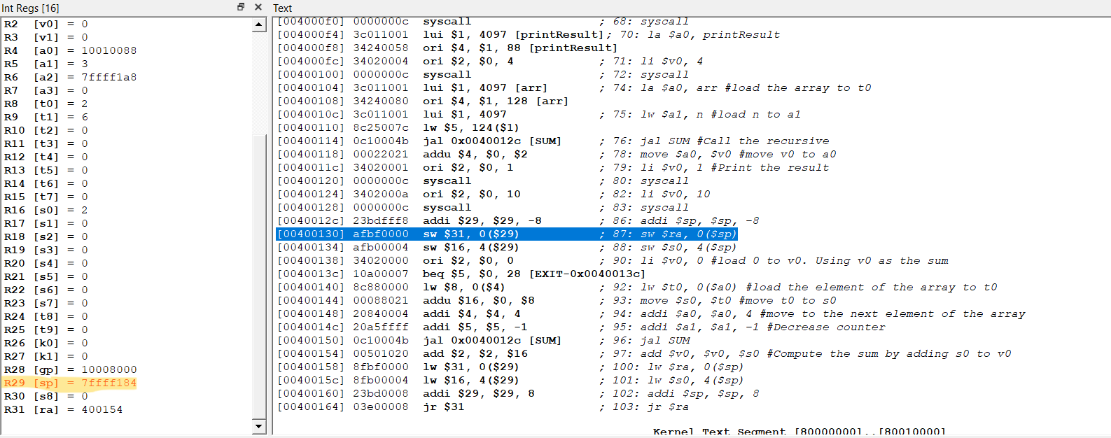

In the third save, the stack pointer is stored in memory address [7ffff17c]

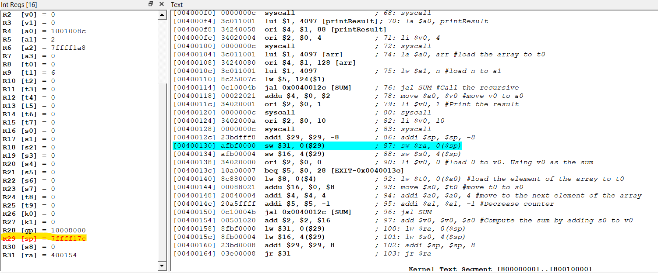

In the fourth save, the stack pointer is stored in memory address [7ffff174]

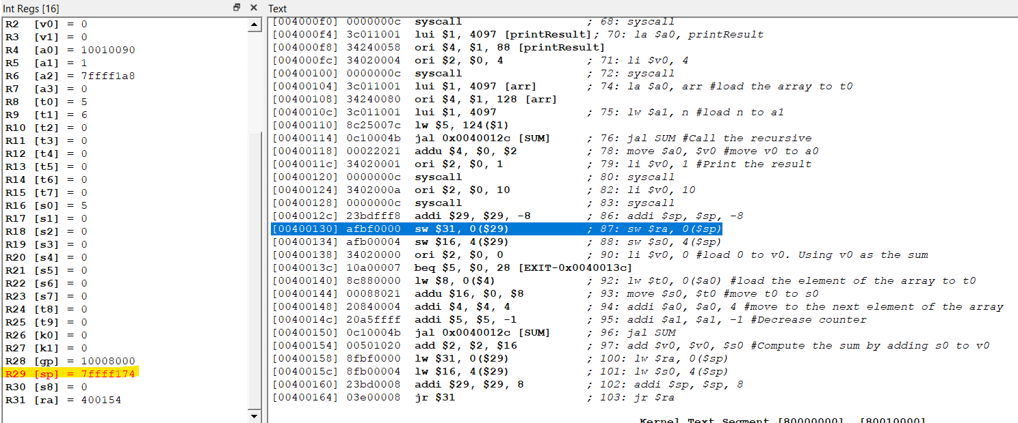

In the fifth save, the stack pointer is stored in memory address [7ffff16c]

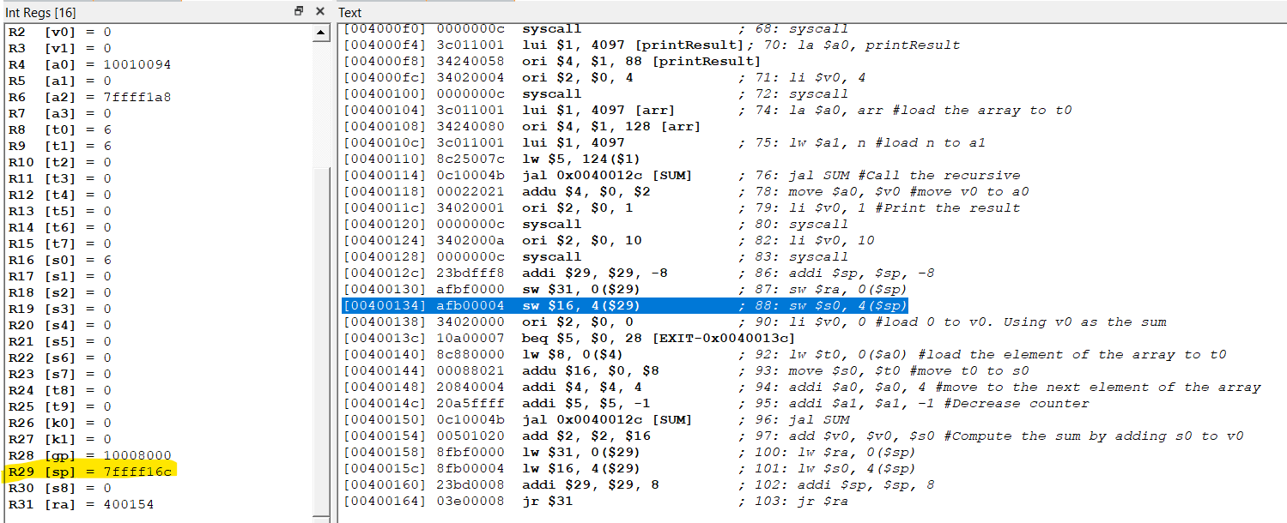

Now using all the value contain in the stack. The stack pointer is stored back to memory address [7ffff174]

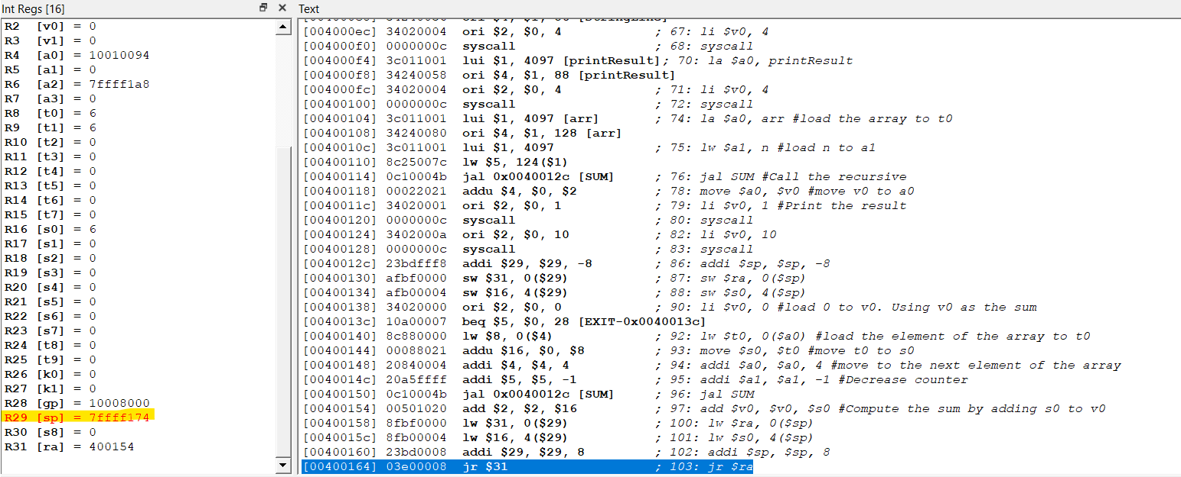

After the add operation, the stack pointer is stored back to memory address [7ffff17c]

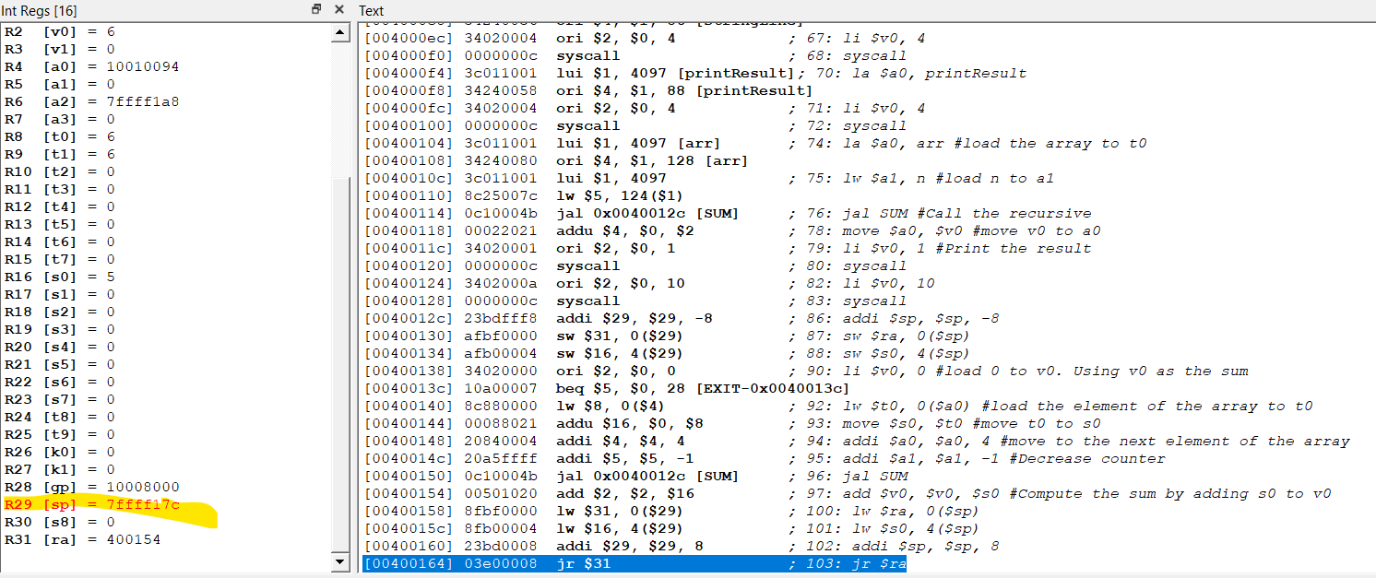

After the add operation, the stack pointer is stored back to memory address [7ffff184]

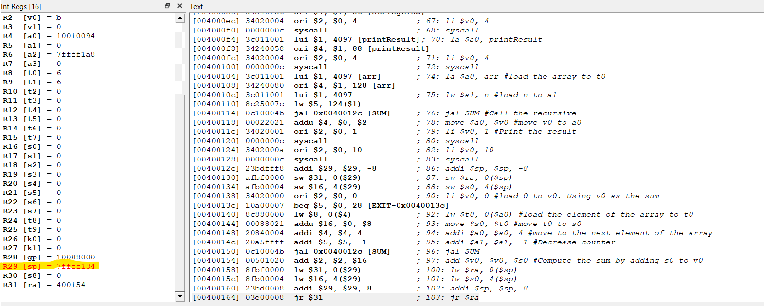

After the add operation, the stack pointer is stored back to memory address [7ffff18c]

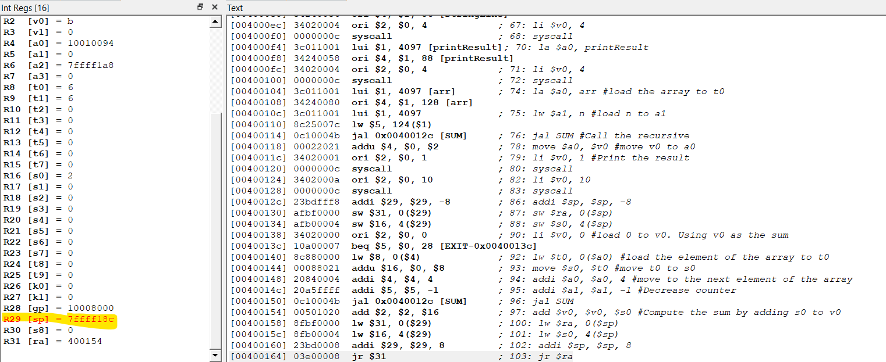

After the add operation, the stack pointer is stored back to memory address [7ffff194]

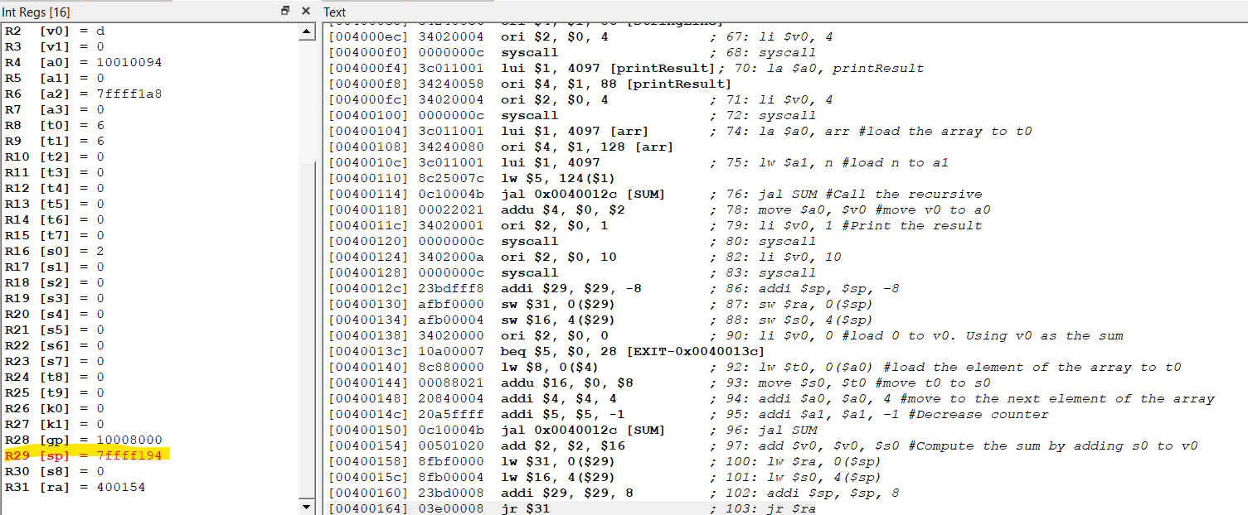

After the add operation, the stack pointer is stored back to memory address [7ffff19c] and the return address is stored back to memory address [00400118] as callee of the main function.

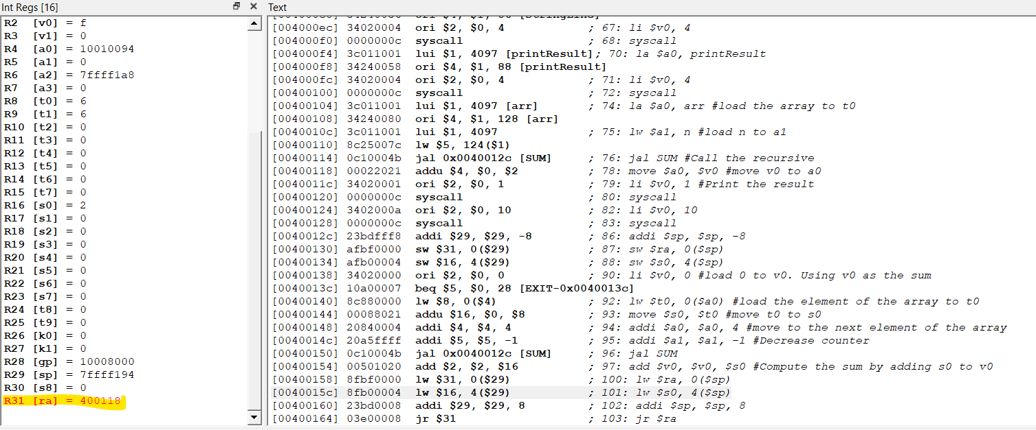

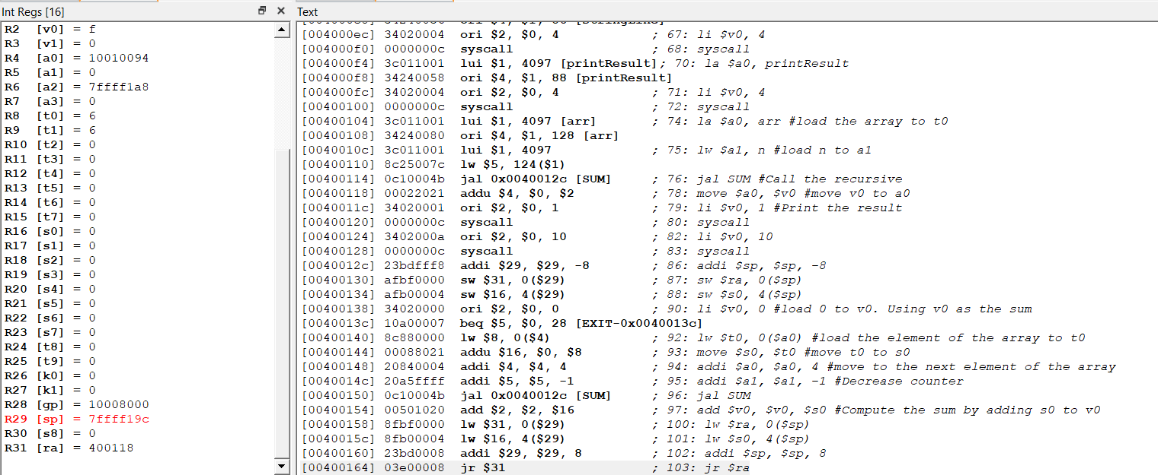

The register v0 and a0 now contain the result

